Hands-On Lab
Lab Manual
A Quick MVCPortlet Tutorial.

Record of change

*A - Added M - Modified D – Deleted

Effective Date | PIC | A*  M, D | Change Description | New Version
10-Dec-2011 | Thach.Le | A | Create. | 0.1

Contents
A Quick MVCPortlet Tutorial. i
Lab 01: A quick portlet tutorial 4
Lab Objectives 4
Prerequisite: 4
Introduction: 4
Exercise 1 – Create web application and portlet. 5
1. Create a Dynamic Web Project 5
2. In project “MVCSubmitForm”, create a portlet “AccountManagement” 5
Package: openones.demo.mvcportlet 5
Exercise 2 – Add MVC framework to portlet. 6
1. Download the latest version of MVCPortlet at “https://mvcportlet.googlecode.com/svn/trunk/MVCPortlet/release”. The current version is used for this document is 0.5.1 at http://mvcportlet.googlecode.com/files/MVCPortlet-0.5.2.zip 6
2. Add MVCPortlet libraries into the portlet. 6
3. Modify portlet.xml 6
4. Create central configuration of the portlet 7
5. Create file “log4j.properties” in folder “MVCSubmitForm/src” with below content: 7
6. Create the screen List by create JSP file “MVCSubmitForm/WebContent/WEB-INF/jsp/List.jsp” with below content: 7
Now you can try to run the project MVCSubmitForm, the List screen is displayed as below: 8
Summary 8
Exercise 3 – Develop form for the portlet. 10
1. Create common scripts (file /MVCSubmitForm/WebContent/scripts/common.js) 10
2. Create layout for screen List (file /MVCSubmitForm/WebContent/WEB-INF/jsp/List.jsp) 10
3. Create layout for screen Add (file /MVCSubmitForm/WebContent/WEB-INF/jsp/Add.jsp) 11
4. Create MVC configuration file “/MVCSubmitForm/WebContent/WEB-INF/mvcportlet-config.xml” 11
5. Create Controller for screen List /MVCSubmitForm/src/openones/demo/mvcportlet/ctrl/ListControl.java 12
6. Create Controller for screen Add (file /MVCSubmitForm/src/openones/demo/mvcportlet/ctrl/AddControl.java) 12
Exercise 4 – Develop form for the portlet. 14
1. Create form beans to capture submitted data from screens “List” and “Add” 14
2. Create controller to handle events of screens “List” and “Add” 16
3. Create busines layer to perform main functionalities of the project 18
4. Copy Tag lib descriptor of portlet into /MVCSubmitForm/WebContent/WEB-INF 19
5. Copy taglib libraries into /MVCSubmitForm/WebContent/WEB-INF/lib 19

Lab 01: A quick portlet tutorial
Estimated time to complete this lab: 45 minutes

Lab Objectives
The objective of this lab is to introduce you how to develop a simple form with MVCPortlet.
- Introduce MVCPortlet.
- Define flow of screen (JSP), data form (Bean) for application.

References:
- http://mvcportlet.googlecode.com.

Prerequisite:
- Completed the hands-on lab of HelloPortlet at: https://docs.google.com/viewer?a=v&pid=explorer&chrome=true&srcid=0B4vjYnf6j5_4NDYxNWVmM2ItMzgxNy00YjIxLWEwMzQtN2Q4Y2Y1M2FhZjhj&hl=en_US

Introduction:
MVCPortlet is Model-View-Controller framework to develop portlet rapidly.
Refer more details at http://mvcportlet.googlecode.com

Exercise 1 – Create web application and portlet.
  - Create a Dynamic Web Project
- Project name: MVCSubmitForm
Note: In “Configure web module setting” dialog, change:
- Context root: portletdriver/dt
  - In project “MVCSubmitForm”, create a portlet “AccountManagement”
  - Package: openones.demo.mvcportlet
 You should run the generated portlet AccountManagement by right-click on project “MVCSubmitForm“, select menu “Run As...> Run on Server...” to choose “OpenPortal Portlet Container 2.x”.
The result is as below:
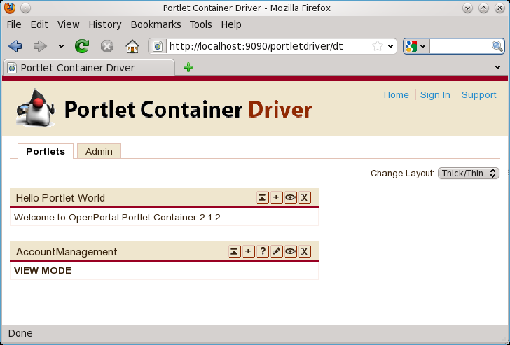
If any problem occurs, please revise the portlet or try to practice the HelloWorld Portlet again. Additionally, please check error in log file of Glassfish in $GLASSFISH_HOME_DIRECTORY/glassfish/domains/domain1/logs/server.log
Then stop the built-in Glashfish in Eclipse to develop the portlet continually.

Exercise 2 – Add MVC framework to portlet.
This exercise helps you using MVCPortlet framework to develop a simple portlet application.
  - Download the latest version of MVCPortlet at “https://mvcportlet.googlecode.com/svn/trunk/MVCPortlet/release”. The current version is used for this document is 0.5.1 at http://mvcportlet.googlecode.com/files/MVCPortlet-0.5.2.zip
  - Add MVCPortlet libraries into the portlet.
- Copy 4 below .jar files into “/MVCSubmitForm/WebContent/WEB-INF/lib”:
  - rocky-common-x.y.z.jar
  - corewa-conf-x.y.z.jar
  - mvcportlet-x.y.z.jar
  - log4j-x.y.z.jar
  - Modify portlet.xml
Open “/MVCSubmitForm/WebContent/WEB-INF/portlet.xml”, then:

- change the portlet class “openones.demo.mvcportlet.AccountManagement” into “openones.portlet.MVCPortlet”
- add 2 parameters “mvcportlet-config” and “contextPath” (optional)
The changed and new items are formatted as blue color following:
...
<portlet>
<description>AccountManagement</description>
<portlet-name>AccountManagement</portlet-name>
<display-name>AccountManagement</display-name>
<portlet-class>openones.portlet.MVCPortlet</portlet-class>
<init-param>
<description>Configuration file</description>
<name>mvcportlet-config</name>
<value>/WEB-INF/mvcportlet-config.xml</value>
</init-param>
<init-param>
<description>Context configuration</description>
<name>contextPath</name>
<value>MVCSubmitForm</value>
</init-param>
<expiration-cache>0</expiration-cache>
...

  - Create central configuration of the portlet
Create file “mvcportlet-config.xml” in folder “/MVCSubmitForm/WebContent/WEB-INF” with following content:
<?xml version="1.0" encoding="UTF-8"?>
<portletapp>
<view-screen>List</view-screen>
<edit-screen>Edit</edit-screen>
<help-screen>Help</help-screen>

<screen id="List" input="/WEB-INF/jsp/List.jsp">
</screen>
</portletapp>
  - Create file “log4j.properties” in folder “MVCSubmitForm/src” with below content:
log4j.rootLogger=debug, stdout, rolling
log4j.appender.stdout=org.apache.log4j.ConsoleAppender
log4j.appender.stdout.layout=org.apache.log4j.PatternLayout
log4j.appender.stdout.layout.ConversionPattern=%5p [%t] (%F:%L) - %m%n

log4j.appender.rolling=org.apache.log4j.RollingFileAppender
log4j.appender.rolling.File=MVCSubmitForm.log
log4j.appender.rolling.MaxFileSize=4000KB
log4j.appender.rolling.MaxBackupIndex=1
log4j.appender.rolling.layout=org.apache.log4j.PatternLayout
log4j.appender.rolling.layout.ConversionPattern=%d - %p - %C - %m%n
  - Create the screen List by create JSP file “MVCSubmitForm/WebContent/WEB-INF/jsp/List.jsp” with below content:
<%@page contentType="text/html"%>
<%@page pageEncoding="UTF-8"%>
<b>
List screen
</b>

Now you can try to run the project MVCSubmitForm, the List screen is displayed as below:
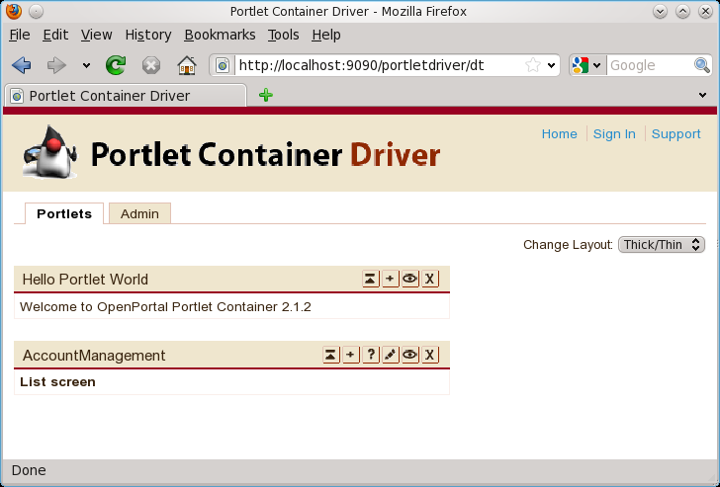
You can delete class “openones.demo.mvcportlet.AccountManagement”. Then run the project again.

Summary
Your have just to use MVCPortlet framework to create a simple portlet. It has a screen “List” without source code.
The portlet is declared in file “WebContent/WEB-INF/portlet.xml”. It declared the MVC configuration in parameter “mvcportlet-config”
<init-param>
<description>Configuration file</description>
<name>mvcportlet-config</name>
<value>/WEB-INF/mvcportlet-config.xml</value>
</init-param>
The configuration “/WEB-INF/mvcportlet-config.xml” declare the home screen in tag “view-screen”. The screen “List” is describes is tag “screen”. It is displayed by JSP page in attribute “input”.
<?xml version="1.0" encoding="UTF-8"?>
<portletapp>
<view-screen>List</view-screen>

<screen id="List" input="/WEB-INF/jsp/List.jsp">
</screen>
</portletapp>
The structrure of files in project is following:
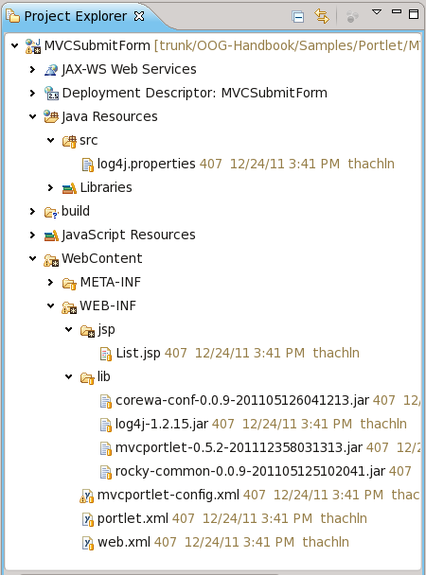
The source code this sample is available at https://open-ones.googlecode.com/svn/trunk/OOG-Handbook/Samples/Portlet/MVCSubmitForm with revision 410.

Exercise 3 – Develop form for the portlet.
This exercise upgrades the portlet AccountManagement in the Exercise 2.
New features:
- The “List” screen has a simple form with an input text to account.
  - The “List” screen has a “Search” button.
- The “List” screen has a “Add” button.
- If “Add” button is clicked, the screen “Add Account” is displayed.
- The “Add Account” screen has a form of inputs “Account”, “First name”, “Last name” and “Birthday”; buttons “Save” and “Go Back”. After “Save” button is clicked, the next screen is the “List”. If “Go Back” is clicked, the screen “List” is displayed.
Screen layouts:
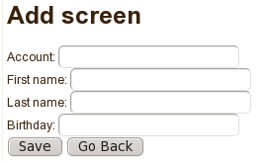
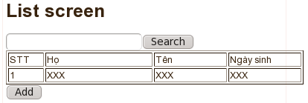
  - Create common scripts (file /MVCSubmitForm/WebContent/scripts/common.js)
function submitAction(formName, eventId) {
var frm = document.forms[formName];
frm.eventId.value = eventId;
frm.submit();
}
  - Create layout for screen List (file /MVCSubmitForm/WebContent/WEB-INF/jsp/List.jsp)
<%@page contentType="text/html" pageEncoding="UTF-8" import="javax.portlet.*"%>
<%@ taglib uri="http://java.sun.com/portlet" prefix="portlet"%>
<portlet:defineObjects/>

<script type="text/javascript" src='/${requestScope.contextPath}/scripts/common.js' ></script>

<H1>List screen</H1>

<form name="<portlet:namespace/>List" action="<portlet:actionURL/>" method="POST">
<input type="hidden" name="screenId" value="List"/>
<input type="hidden" name="eventId" value=""/>

<%-- Search condition --%>
<input type="text" name="account" value=""/><input type="button" name="search" value="Search" onclick='submitAction("<portlet:namespace/>List", "search");'/><br/>

<%-- Search result --%>
<table border="1" width="400px">
<tr>
<td width="5px">STT</td>
<td width="90px">Họ</td>
<td width="60px">Tên</td>
<td width="60px">Ngày sinh</td>
</tr>
<tr>
<td>1</td>
<td>XXX</td>
<td>XXX</td>
<td>XXX</td>
</tr>
</table>

<input type="button" name="add" value="Add" onclick='submitAction("<portlet:namespace/>List","add");'/>
</form>

  - Create layout for screen Add (file /MVCSubmitForm/WebContent/WEB-INF/jsp/Add.jsp)
<%@page contentType="text/html" pageEncoding="UTF-8"%>
<%@ page import="javax.portlet.*"%>
<%@ taglib uri="http://java.sun.com/portlet" prefix="portlet"%>
<portlet:defineObjects/>

<script type="text/javascript" src='/${requestScope.contextPath}/scripts/common.js' ></script>

<H1>Add screen</H1>

<form name="<portlet:namespace/>Add" action="<portlet:actionURL/>" method="POST">
<input type="hidden" name="screenId" value="Add"/>
<input type="hidden" name="eventId" value=""/>

<%-- Search result --%>
Account: <input name="account" value="${requestScope.formBean.account}"/><br/>
First name: <input name="account" value="${requestScope.formBean.firstName}"/><br/>
Last name: <input name="account" value="${requestScope.formBean.firstName}"/><br/>
Birthday: <input name="account" value="${requestScope.formBean.birthDay}"/><br/>

<input type="button" name="save" value="Save" onclick='submitAction("<portlet:namespace/>Add","save");'/>
<input type="button" name="goBack" value="Go Back" onclick='submitAction("<portlet:namespace/>Add","goBack");'/>
</form>
  - Create MVC configuration file “/MVCSubmitForm/WebContent/WEB-INF/mvcportlet-config.xml”
<?xml version="1.0" encoding="UTF-8"?>
<portletapp>
<view-screen>List</view-screen>
<edit-screen>Edit</edit-screen>
<help-screen>Help</help-screen>

<screen id="List" input="/WEB-INF/jsp/List.jsp" control="openones.demo.mvcportlet.ctrl.ListControl">
<event id="search" procId="procSearch"/>
<event id="add" redirect="yes" nextScreen="/WEB-INF/jsp/Add.jsp"/>
</screen>

<screen id="Add" input="/WEB-INF/jsp/List.jsp" control="openones.demo.mvcportlet.ctrl.AddControl">
<event id="save" procId="procSave" nextScreen="/WEB-INF/jsp/List.jsp"/>
<event id="goBack" redirect="yes" nextScreen="/WEB-INF/jsp/List.jsp"/>
</screen>

</portletapp>
  - Create Controller for screen List /MVCSubmitForm/src/openones/demo/mvcportlet/ctrl/ListControl.java
package openones.demo.mvcportlet.ctrl;

import java.io.IOException;
import java.util.Map;

import javax.portlet.ActionRequest;
import javax.portlet.ActionResponse;
import javax.portlet.PortletException;

import org.apache.log4j.Logger;

import openones.corewa.BaseOutForm;
import openones.portlet.control.BaseControl;

public class ListControl extends BaseControl {
final static Logger LOG = Logger.getLogger("ListControl");

public BaseOutForm procSearch(ActionRequest request, Map<String, Object> reqMap, ActionResponse response)
throws PortletException, IOException {
LOG.debug("procSearch.START");

return super.init(request, reqMap, response);
}
}
  - Create Controller for screen Add (file /MVCSubmitForm/src/openones/demo/mvcportlet/ctrl/AddControl.java)
package openones.demo.mvcportlet.ctrl;

import java.io.IOException;
import java.util.Map;

import javax.portlet.ActionRequest;
import javax.portlet.ActionResponse;
import javax.portlet.PortletException;

import openones.corewa.BaseOutForm;
import openones.portlet.control.BaseControl;

import org.apache.log4j.Logger;

public class AddControl extends BaseControl {
final static Logger LOG = Logger.getLogger("AddControl");

public BaseOutForm procSave(ActionRequest request, Map<String, Object> reqMap, ActionResponse response)
throws PortletException, IOException {
LOG.debug("procSave.START");

return super.init(request, reqMap, response);
}
}
Now, you can try to run the project. Then click on buttons.
On “List” screen , button “Add” will forward to screen “Add”.
On “Add” screen, buttons “Save” and “Go Back” will forward to screen “List.
There is no business process for button “Search” and “Add” except logging statements.

The source code this version is available at https://open-ones.googlecode.com/svn/trunk/OOG-Handbook/Samples/Portlet/MVCSubmitForm with revision 413.

Exercise 4 – Develop form for the portlet.
This exercise upgrades the portlet AccountManagement in the Exercise 3.
New features:
- Build form beans to capture submitted data from screen List and Search.
- Build a static array to contain the data.
- Add processing for funtions “Add” and “Search”
  - Create form beans to capture submitted data from screens “List” and “Add”
Create class openones.demo.mvcportlet.form.ListForm with following content:
package openones.demo.mvcportlet.form;

import java.util.List;

import openones.corewa.BaseInForm;

/**
* Capture submitted data from screen List.
* @author Thach Le
*/
public class ListForm extends BaseInForm {
/** Capture data from field account. */
private String account;

/** Search result. */
private List<AccountForm> accountList;
/**
* Get value of account.
* @return the account
*/
public String getAccount() {
return account;
}

/**
* Set the value for account.
* @param account the account to set
*/
public void setAccount(String account) {
this.account = account;
}

/**
* Get value of accountList.
* @return the accountList
*/
public List<AccountForm> getAccountList() {
return accountList;
}

/**
* Set the value for accountList.
* @param accountList the accountList to set
*/
public void setAccountList(List<AccountForm> accountList) {
this.accountList = accountList;
}
}
Create class openones.demo.mvcportlet.form.AccountForm with following content:
package openones.demo.mvcportlet.form;

import openones.corewa.BaseInForm;

/**
* Capture submitted data from screen Add.
* @author Thach Le
*/
public class AccountForm extends BaseInForm {
/** Capture data from field account. */
private String account;

/** Capture data from field firstName. */
private String firstName;

/** Capture data from field lastName. */
private String lastName;

/** Capture data from field birthDay. */
private String birthDay;

/**
* Get value of account.
* @return the account
*/
public String getAccount() {
return account;
}

/**
* Set the value for account.
* @param account the account to set
*/
public void setAccount(String account) {
this.account = account;
}

/**
* Get value of firstName.
* @return the firstName
*/
public String getFirstName() {
return firstName;
}

/**
* Set the value for firstName.
* @param firstName the firstName to set
*/
public void setFirstName(String firstName) {
this.firstName = firstName;
}

/**
* Get value of lastName.
* @return the lastName
*/
public String getLastName() {
return lastName;
}

/**
* Set the value for lastName.
* @param lastName the lastName to set
*/
public void setLastName(String lastName) {
this.lastName = lastName;
}

/**
* Get value of birthDay.
* @return the birthDay
*/
public String getBirthDay() {
return birthDay;
}

/**
* Set the value for birthDay.
* @param birthDay the birthDay to set
*/
public void setBirthDay(String birthDay) {
this.birthDay = birthDay;
}
}

  - Create controller to handle events of screens “List” and “Add”
a) Create class openones.demo.mvcportlet.ctrl.ListControl following content:
- package openones.demo.mvcportlet.ctrl;

- import java.io.IOException;
- import java.util.List;
- import java.util.Map;

- import javax.portlet.ActionRequest;
- import javax.portlet.ActionResponse;
- import javax.portlet.PortletException;

- import org.apache.log4j.Logger;

- import openones.corewa.BaseOutForm;
- import openones.corewa.ReqUtil;
- import openones.demo.mvcportlet.biz.AccountBiz;
- import openones.demo.mvcportlet.form.AccountForm;
- import openones.demo.mvcportlet.form.ListForm;
- import openones.portlet.control.BaseControl;

- /**
- * @author Thach Le
- */
- public class ListControl extends BaseControl {
- /** Logger. */
- static final Logger LOG = Logger.getLogger("ListControl");

- /**
- * Process "Search" button in the screen "List".
- * @param request client request
- * @param reqMap data request is built from user request
- * @param response response for client
- * @return result data of the action
- * @throws PortletException error of Portlet
- * @throws IOException error of Portlet
- */
- public BaseOutForm procSearch(ActionRequest request, Map<String, Object> reqMap, ActionResponse response)
- throws PortletException, IOException {
- LOG.debug("procSearch.START");
- // Parse request into form bean
- ListForm searchCondBean = (ListForm) ReqUtil.getData(reqMap, ListForm.class);

- // Debug
- LOG.debug("Search account:" + searchCondBean.getAccount());

- List<AccountForm> accountList = AccountBiz.search(searchCondBean.getAccount());

- // Prepare output form to return the action
- BaseOutForm outForm = new BaseOutForm();
- outForm.putRequest("formBean", searchCondBean);
- outForm.putRequest("accountList", accountList);

- return outForm;
- }
- }
Explanation:
MVCPortlet framework inwokes method “procSearch” automatically after user click on “Search” button from screen “List”.
In List.jsp, the screenId is defined in a hidden field
<input type="hidden" name="screenId" value="List"/>
The event of “Search” button is described in second parameter of java script “submiAction”.
<input type="button" name="search" value="Search" onclick='submitAction("<portlet:namespace/>List", "search");'/>
b) Create class openones.demo.mvcportlet.ctrl.AddControl following content:
package openones.demo.mvcportlet.ctrl;

import java.io.IOException;
import java.util.Map;

import javax.portlet.ActionRequest;
import javax.portlet.ActionResponse;
import javax.portlet.PortletException;

import openones.corewa.BaseOutForm;
import openones.corewa.ReqUtil;
import openones.demo.mvcportlet.biz.AccountBiz;
import openones.demo.mvcportlet.form.AccountForm;
import openones.portlet.control.BaseControl;

import org.apache.log4j.Logger;

/**
* @author Thach Le
*/
public class AddControl extends BaseControl {
/** Logger. */
static final Logger LOG = Logger.getLogger("AddControl");

/**
* Process "Save" button in the screen "Add".
* @param request client request
* @param reqMap data request is built from user request
* @param response response for client
* @return result data of the action
* @throws PortletException error of Portlet
* @throws IOException error of Portlet
*/
public BaseOutForm procSave(ActionRequest request, Map<String, Object> reqMap, ActionResponse response)
throws PortletException, IOException {
LOG.debug("procSave.START");

// Parse request into form bean
AccountForm accountBean = (AccountForm) ReqUtil.getData(reqMap, AccountForm.class);

// Debug
LOG.debug("Add account:" + accountBean.getAccount() + ";firstName=" + accountBean.getFirstName() + ";lastName="
+ accountBean.getLastName() + ";birthDay=" + accountBean.getBirthDay());

// Invoke Business layer
AccountBiz.addAccount(accountBean);

// Prepare output form to return the action
BaseOutForm outForm = new BaseOutForm();
outForm.putRequest("accountBean", accountBean);

return outForm;
}
}

  - Create busines layer to perform main functionalities of the project
Create class openones.demo.mvcportlet.biz.AccountBiz following content:
package openones.demo.mvcportlet.biz;

import java.util.ArrayList;
import java.util.Date;
import java.util.HashMap;
import java.util.List;
import java.util.Map;

import openones.demo.mvcportlet.form.AccountForm;

/**
* @author Thach Le
*/
public final class AccountBiz {
/** Static Map to contain accounts, key is account id. */
private static Map<String, AccountForm> accountDataMap = new HashMap<String, AccountForm>();

static {
// Demo data
AccountForm accountInfo = new AccountForm();
accountInfo.setAccount("open-ones");
accountInfo.setFirstName("All");
accountInfo.setLastName("Share");
accountInfo.setBirthDay(new Date().toString());

accountDataMap.put(accountInfo.getAccount(), accountInfo);
}

/** Avoid caller create a new instance of AccountBiz. */
private AccountBiz() {
}

/**
* Demo add account to data layer.
* @param account demo account.
*/
public static void addAccount(AccountForm account) {
accountDataMap.put(account.getAccount(), account);
}

/**
* Search account information with given condition.
* @param searchAccount search condition. Searching by "start with"
* @return list of account data which has account start with searched account.
*/
public static List<AccountForm> search(String searchAccount) {
List<AccountForm> resultList = new ArrayList<AccountForm>();

for (String account : accountDataMap.keySet()) {
if (account.startsWith(searchAccount)) {
resultList.add(accountDataMap.get(account));
}
}

return resultList;
}
}
Explanation:
AccountBiz uses a HashMap to contains the data (to avoid the complex code if connect to database). It contain a sample record of Account information (account=”openones”, firstName=”All”, lastName=”Share”, birthDay=current Date).
  - Copy Tag lib descriptor of portlet into /MVCSubmitForm/WebContent/WEB-INF
Download file http://mvcportlet.googlecode.com/files/sun-portlet.tld and save it into /MVCSubmitForm/WebContent/WEB-INF.
It will notice to Eclipse does not display errors about taglib is JSP.
  - Copy taglib libraries into /MVCSubmitForm/WebContent/WEB-INF/lib
Download file http://mvcportlet.googlecode.com/files/jstl-1.1.2.jar.zip, extract and copy jstl-1.1.2.jar, standard-1.1.2.jar into /MVCSubmitForm/WebContent/WEB-INF/lib

Now, you can try to run the portlet to explore the Search and Add features. This project describe the rapid simple capture data from the request of portlet into the Java bean. Addtionally, it show the flow of screens is defined centrally in XML configuration.

